Engineering Model Description | I-Beam | Prepared by: Kaveh BABANEZHAD and Jean BIGEON



**1. Introduction**

This document focuses on describing the model related to a case study where one will try to minimize the mass and/or deflection of an I-beam in an engineering design scenario under specific constraints [1], [2]. In the following, the definitions required to successfully shape and solve an optimization problem are gathered under Tables 1-5.

**Table. 1 - Variables and design parameters of the model [1-2]**

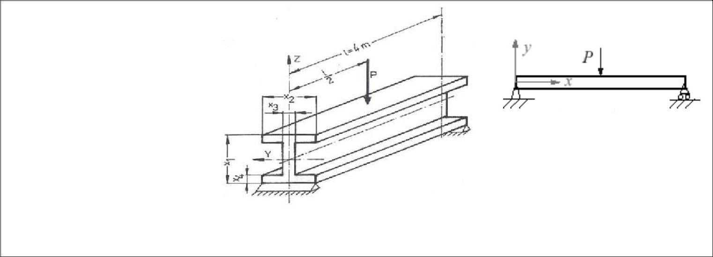

|  |  |
| --- | --- |
| *L* | Length (*m*) |
| *E* | Elastic module (*Pa*) |
| *P* | Force (*N*) |
| Density | in (*Kg/m3*) |
| *x1* | Beam height (*m*) |
| *x2* | Flange width (*m*) |
| *x3* | Flange thickness (*m*) |
| *x4* | Web thickness (*m*) |

With values:

*L=4, E=2×1011,*

*P=104,* Density*=7800*

Material assumption:

*Steel (ASTM-A36)*

**Table. 2 –Definition of displacement in the context of the studied I-beam [1-2]**

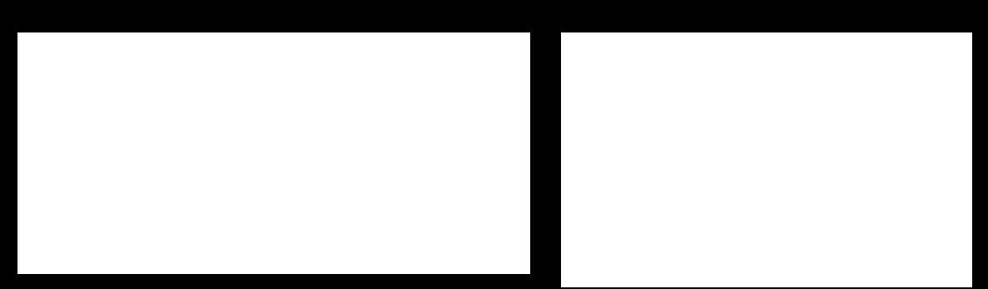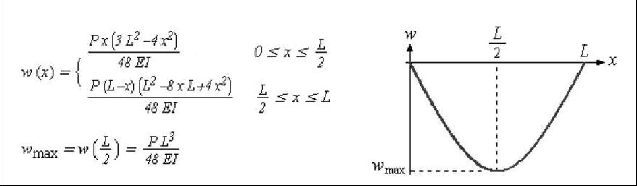

**Table. 3 –Definition of moment and maximum bending stress in the context of the studied I-beam [1-2]**

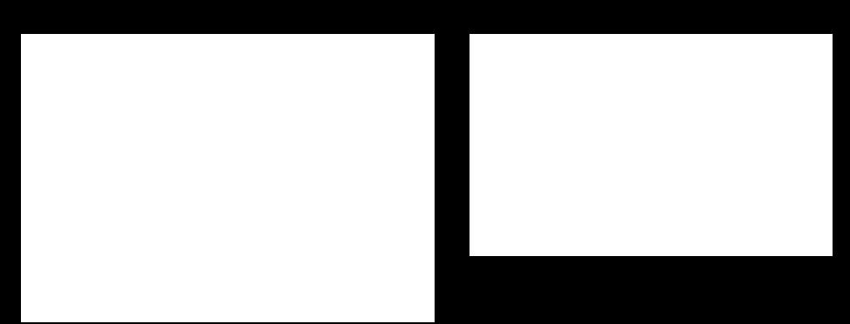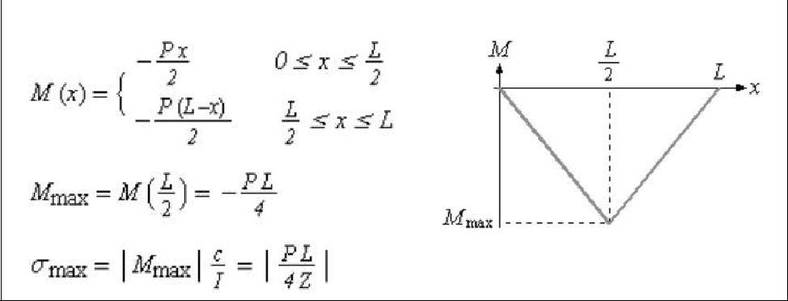

**1**

Engineering Model Description | I-Beam | Prepared by: Kaveh BABANEZHAD



**Table. 4 –Override variable Z in Table.3**

Where:

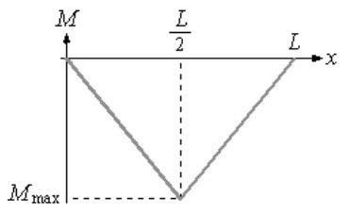

*Y* Perpendicular distance from/to neutral axis (*m*)

*I* Moment of Inertia (*m4*)

**Table. 5 –Calculation of the moment of inertia in I-beams following the override in Tbl. 4**

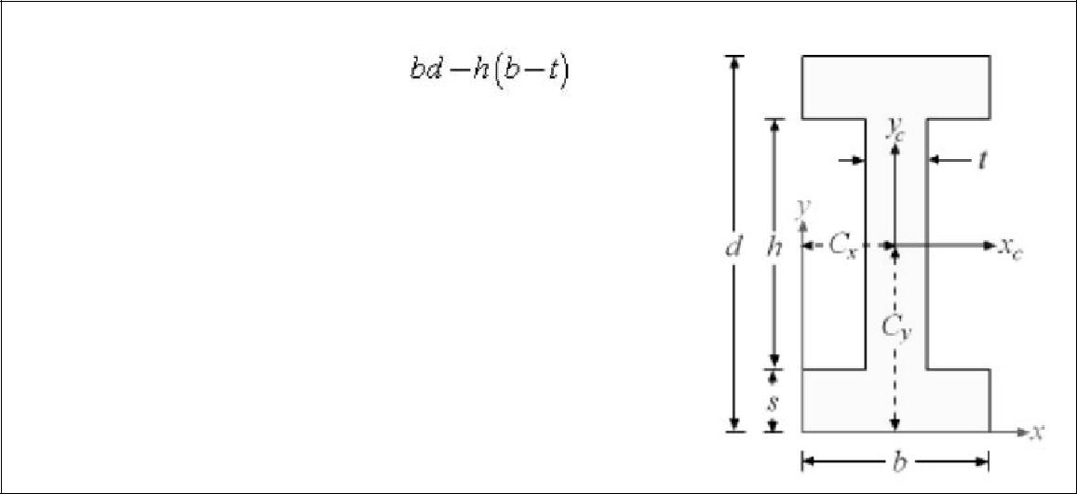

|  |  |  |  |  |
| --- | --- | --- | --- | --- |
| Surface Area (*m2*) |  |  |  |  |
| Moment of inertia | 3 | 3 | 2 |  |
| around the *xc* axis (*m4*) | ℎ + 2 + 6 (ℎ+ ) | | |  |
|  |  | 12 |  |
|  |  |  |  |

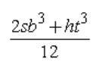

Moment of inertia around the *yc* axis (*m4*)



Mass (*Kg*)

Three different optimization problems for the I-beam structures have been defined in [1-2] as follows under Tables 6-11.

**Table. 6 –Optimization problem one [1-2]**

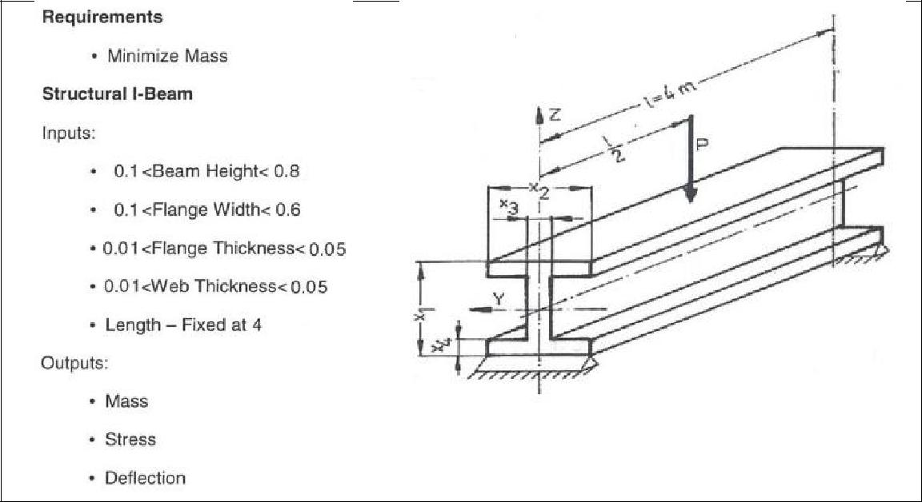

**2**

Engineering Model Description | I-Beam | Prepared by: Kaveh BABANEZHAD



**Tbl. 7 –(Non-reformulated) Model for optimization problem one**

|  |  |  |  |  |  |  |  |  |  |  |  |  |  |  |  |  |  |  |  |  |  |  |  |  |  |  |  |  |
| --- | --- | --- | --- | --- | --- | --- | --- | --- | --- | --- | --- | --- | --- | --- | --- | --- | --- | --- | --- | --- | --- | --- | --- | --- | --- | --- | --- | --- |
|  | Objective | |  |  |  | Minimize= ∗∗ | | | | | | | | | | | | | | |  |  |  |  |  |  |  |  |
|  | Function(s) | |  |  |  |  |  |  |  |  |  |  |  |
|  |  |  |  |  |  |  |  |  |  |  |  |  |  |  |  |  |  |  |  |  |  |  |  |  |  |  |
|  | Output | | None |  |  |  |  |  |  |  |  |  |  |  |  |  |  |  |  |  |  |  |  |  |  |  |  |  |
|  | Constraints | |  |  |  |  |  |  |  |  |  |  |  |  |  |  |  |  |  |  |  |  |  |  |  |  |  |
|  |  |  |  |  |  |  |  |  |  |  |  |  |  |  |  |  |  |  |  |  |  |  |  |  |  |  |
|  | Input | |  |  |  | ∶[0.10 0.80] | |  |  |  |  |  |  |  |  |  |  |  |  |  |  |  |  |  |  |  |  |  |
|  |  |  |  |  |  |  |  |  |  |  |  |  |  |  |  |  |  |  |  |  |  |  |  |  |  |  |
|  | Constraints | |  |  |  | 1 |  |  |  |  |  |  |  |  |  |  |  |  |  |  |  |  |  |  |  |  |  |  |
|  |  |  |  | ∶[0.10 0.60] | |  |  |  |  |  |  |  |  |  |  |  |  |  |  |  |  |  |  |  |  |  |
|  | (Bounds) | |  |  |  |  |  |  |  |  |  |  |  |  |  |  |  |  |  |  |  |  |  |  |  |  |
|  | Within intervals | | | 2 |  |  |  |  |  |  |  |  |  |  |  |  |  |  |  |  |  |  |  |  |  |  |
|  |  |  | ∶[0.01 0.05] | |  |  |  |  |  |  |  |  |  |  |  |  |  |  |  |  |  |  |  |  |  |
|  |  |  |  |  |  |  |  |  |  |  |  |  |  |  |  |  |  |  |  |  |  |  |  |  |  |  |
|  |  |  |  |  |  | 3 |  |  |  |  |  |  |  |  |  |  |  |  |  |  |  |  |  |  |  |  |  |  |
|  |  |  |  |  |  | ∶ 0.01 0.05 | |  |  |  |  |  |  |  |  |  |  |  |  |  |  |  |  |  |  |  |  |  |
|  |  |  |  |  |  | 4 |  |  |  |  |  |  |  |  |  |  |  |  |  |  |  |  |  |  |  |  |  |  |
|  | Internal | |  |  |  | == 4 |  |  |  |  |  |  |  |  |  |  |  |  |  |  |  |  |  |  |  |  |  |  |
|  | Parameters | | With value(s) | |  | == 104 | |  |  |  |  |  |  |  |  |  |  |  |  |  |  |  |  |  |  |  |  |  |
|  |  |  |  | == 2 × 105 | |  |  |  |  |  |  |  |  |  |  |  |  |  |  |  |  |  |  |  |  |  |
|  |  |  |  |  |  |  |  |  |  |  |  |  |  |  |  |  |  |  |  |  |  |  |  |  |  |  |
|  |  |  |  |  | == 7800 | | |  |  |  |  |  |  |  |  |  |  |  |  |  |  |  |  |  |  |  |  |  |
|  |  |  |  |  |  | = ∗ −( −2 )( − ) | | | | | | | | | | | | | | | | | |  |  |  |  |  |
|  |  |  |  |  |  |  |  | 2 |  |  | 1 | | |  | 1 | | 4 | | | | 2 | | 3 |  |  |  |  |  |
|  |  |  |  |  |  |  |  |  | 3 | |  |  |  |  | 3 | |  |  |  |  |  |  |  | 2 |  |  |  |  |
|  |  |  |  |  |  |  | ( −2∗ ) ∗ + 2∗ ∗ + 6∗ ∗ ∗( − ) | | | | | | | | | | | | | | | | | | | |  |  |
|  |  |  |  |  |  | = | 1 | 4 |  |  | 3 | | |  | 4 | | 2 | | |  | 4 2 | | 1 4 |  |  |  |  |  |
|  |  |  |  |  |  |  |  |  |  |  |  |  |  |  |  |  |  |  |  |  |  |  |  |  |  |  |  |
|  |  |  |  |  |  |  |  |  |  |  |  |  |  |  | 12 | | | |  |  |  |  |  |  |  |  |  |  |
|  |  |  |  |  |  |  |  |  |  |  |  |  |  |  |  |  |  |  |  |  |  |  |  |  |
|  |  |  |  |  |  |  |  |  |  |  |  |  |  | 3 |  |  |  |  |  |  | 3 |  |  |  |  |  |  |  |
|  |  |  |  |  |  |  |  |  |  | 2∗ ∗ + −2∗ ∗ | | | | | | | | | | | | |  |  |  |  |  |  |
|  |  |  | Simplified equation(s) | | | | = | |  |  | 4 | | | 2 |  |  | 14 | | | | 3 |  |  |  |  |  |  |  |
|  |  |  |  |  |  |  |  |  |  |  |  |  |  |  | 12 | | | |  |  |  |  |  |  |  |  |  |  |
|  |  |  |  |  |  |  |  |  |  |  |  |  |  |  |  |  |  |  |  |  |  |  |  |  |
|  |  |  |  |  |  |  |  |  |  |  | = + | | | | | | | | | |  |  |  |  |  |  |  |  |
|  |  |  |  |  |  |  |  |  |  |  |  |  |  |  | | |  |  |  | |  |  |  |  |  |  |  |  |
|  |  |  |  |  |  |  |  |  |  |  |  |  |  |  |  |  | | | | |  |  |  |  |  |  |  |  |
|  |  |  |  |  |  |  |  |  |  |  |  |  |  | = |  |  | 1 |  |  |  |  |  |  |  |  |  |  |  |
|  |  |  |  |  |  |  |  |  |  |  |  |  |  | 2 | | |  |  |  |  |  |  |  |  |  |  |  |
|  |  |  |  |  |  |  |  |  |  |  |  |  |  |  |  |  |  |  |  |  |  |  |  |  |  |
|  |  |  |  |  |  |  |  |  |  |  |  |  |  |  |  |  |  |  |  |  |  |  |  |  |  |  |  |  |
|  | Output | | Mass |  |  |  | = ∗∗ | | | | | | | | | | | | | |  |  |  |  |  |  |  |  |
|  | (To Display) | |  |  |  |  |  |  |  |  |  |  |  |
|  |  |  |  |  |  |  |  |  |  |  |  |  |  |  |  |  |  |  |  |  |  |  |  |  |  |  |
|  | Max. |  |  |  | = | | | | | | ∗ ∗ | | | | | | | |  |  |  |  |  |  |  |  |
|  |  |  |  |  |  |  |  |  |  |  |  |  |  |
|  |  |  |  |  |  |  |  |  |  |  |  |  |  |  |
|  |  |  | Stress |  |  |  |  | | | | | |  |  |  |  |  |  |  |  |  |  |
|  |  |  |  |  |  |  | | | |  |  |  | 4 ∗ | | | | | | |  |  |  |  |  |  |  |  |
|  |  |  |  |  |  |  |  |  |  |  |  |  |  |  |  | | | | | |  |  |  |  |  |  |  |  |
|  |  |  | Max. |  |  |  |  |  |  |  |  |  |  |  | 3 | | |  |  |  |  |  |  |  |  |  |  |  |
|  |  |  |  |  |  |  |  | = | |  |  |  | ∗ | | | | | | |  |  |  |  |  |  |  |  |
|  |  |  | Deflection |  |  |  |  |  |  |  |  |  |  |  |  |  |  |  |  |  |  |  |  |  |  |
|  |  |  |  |  |  |  |  |  |  |  |  |  |  |  |  |  |  |  |  |  |  |  |  |  |
|  |  |  |  |  |  |  |  | |  |  |  | 48 ∗ ∗ | | | | | | | | |  |  |  |  |  |  |  |  |
|  |  |  |  |  |  |  |  |  |  |  |  |  |  |  |  |  |  |  | | |  |  |  |  |  |  |  |  |
|  |  |  |  | **Tbl. 8 –Optimization problem two [1-2]** | | | | | | | | | | |  |  |  |  |  |  |  |  |  |  |  |  |  |  |
|  |  |  |  |  |  |  |  |  |  |  |  |  |  |  |  |  |  |  |  |  |  |  |  |  |  |  |  |  |
|  |  |  |  |  |  |  |  |  |  |  |  |  |  |  |  |  |  |  |  |  |  |  |  |  |  |  |  |  |
|  |  |  |  |  |  |  |  |  |  |  |  |  |  |  |  |  |  |  |  |  |  |  |  |  |  |  |  |  |

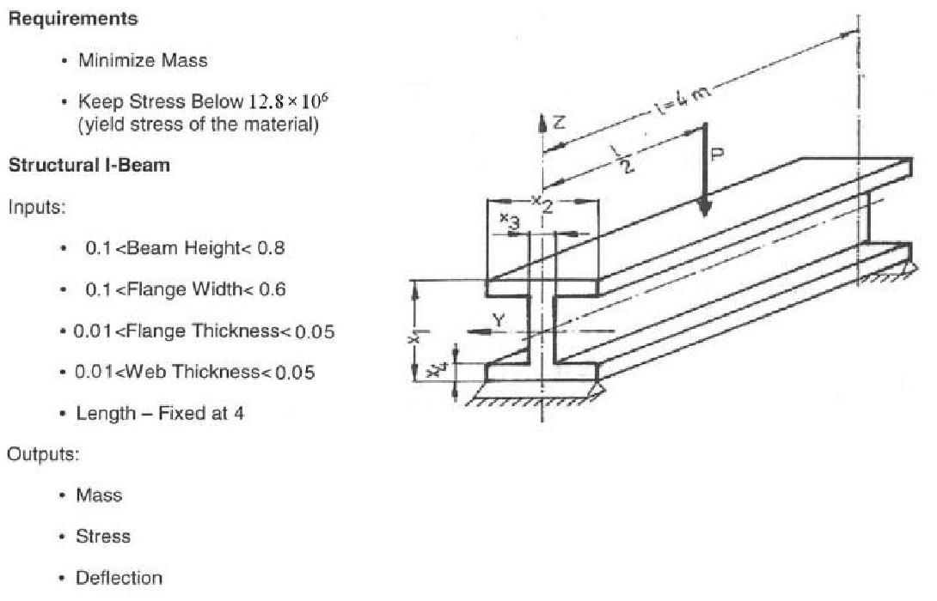

**3**

Engineering Model Description | I-Beam | Prepared by: Kaveh BABANEZHAD



**Tbl. 9 –(Non-reformulated) Model for optimization problem two**

|  |  |  |  |  |  |  |  |  |  |  |  |  |  |  |  |  |  |  |  |  |  |  |  |  |  |  |  |  |  |  |  |  |
| --- | --- | --- | --- | --- | --- | --- | --- | --- | --- | --- | --- | --- | --- | --- | --- | --- | --- | --- | --- | --- | --- | --- | --- | --- | --- | --- | --- | --- | --- | --- | --- | --- |
|  | Objective | |  |  | Minimize= ∗∗ | | | | | | | | | | | | | | | | | | |  |  |  |  |  |  |  |  |  |
|  | Function(s) | |  |  |  |  |  |  |  |  |  |  |  |
|  |  |  |  |  |  |  |  |  |  |  |  |  |  |  |  |  |  |  |  |  |  |  |  |  |  |  |  |  |  |  |
|  | Output | |  |  |  |  | ∗ ∗ | | | |  |  |  |  |  |  |  |  |  |  |  |  |  |  |  |  |  |  |  |  |  |  |
|  | Constraints | | Within intervals | | = | | ∶ 0 12.8 × 10 | | | | | | | | | | | | | | 6 | |  |  |  |  |  |  |
|  |  | |  | |  |  |  |  |  |  |
|  |  |  |  |  | 4 ∗ | | | , |  |  |  |  |  |  |  |  |
|  |  |  |  |  |  |  |  |  |  | | | | |  |  |  |  |  |  |  |  |  |  |  |  |  |  |  |  |
|  |  |  |  |  |  |  |  |  | |  |  |  |  |  |  |  |  |  |  |  |  |  |  |  |  |  |  |  |  |  |  |  |
|  | Input | |  |  | ∶[0.10 0.80] | | | | | |  |  |  |  |  |  |  |  |  |  |  |  |  |  |  |  |  |  |  |  |  |  |
|  |  |  |  |  |  |  |  |  |  |  |  |  |  |  |  |  |  |  |  |  |  |  |  |  |  |  |
|  | Constraints | |  |  | 1 |  |  |  |  |  |  |  |  |  |  |  |  |  |  |  |  |  |  |  |  |  |  |  |  |  |  |  |
|  |  |  | ∶[0.10 0.60] | | | | | |  |  |  |  |  |  |  |  |  |  |  |  |  |  |  |  |  |  |  |  |  |  |
|  | (Bounds) | |  |  |  |  |  |  |  |  |  |  |  |  |  |  |  |  |  |  |  |  |  |  |  |  |
|  | Within intervals | | 2 |  |  |  |  |  |  |  |  |  |  |  |  |  |  |  |  |  |  |  |  |  |  |  |  |  |  |  |
|  |  |  | ∶[0.01 0.05] | | | | | |  |  |  |  |  |  |  |  |  |  |  |  |  |  |  |  |  |  |  |  |  |  |
|  |  |  |  |  |  |  |  |  |  |  |  |  |  |  |  |  |  |  |  |  |  |  |  |  |  |  |
|  |  |  |  |  | 3 |  |  |  |  |  |  |  |  |  |  |  |  |  |  |  |  |  |  |  |  |  |  |  |  |  |  |  |
|  |  |  |  |  | ∶ 0.01 0.05 | | | | | |  |  |  |  |  |  |  |  |  |  |  |  |  |  |  |  |  |  |  |  |  |  |
|  |  |  |  |  | 4 |  |  |  |  |  |  |  |  |  |  |  |  |  |  |  |  |  |  |  |  |  |  |  |  |  |  |  |
|  | Internal | |  |  | == 4 | | |  |  |  |  |  |  |  |  |  |  |  |  |  |  |  |  |  |  |  |  |  |  |  |  |  |
|  | Parameters | | With value(s) | | == 104 | | | | |  |  |  |  |  |  |  |  |  |  |  |  |  |  |  |  |  |  |  |  |  |  |  |
|  |  |  | == 2 × 105 | | | | |  |  |  |  |  |  |  |  |  |  |  |  |  |  |  |  |  |  |  |  |  |  |  |
|  |  |  |  |  |  |  |  |  |  |  |  |  |  |  |  |  |  |  |  |  |  |  |  |  |  |  |  |
|  |  |  |  | == 7800 | | | | | | |  |  |  |  |  |  |  |  |  |  |  |  |  |  |  |  |  |  |  |  |  |  |
|  |  |  |  |  |  | = ∗ −( −2 )( − ) | | | | | | | | | | | | | | | | | | | | | |  |  |  |  |  |
|  |  |  |  |  |  |  |  |  |  |  | 2 |  |  | 1 | | |  | 1 | | 4 | | | |  | 2 | | 3 |  |  |  |  |  |
|  |  |  |  |  |  |  |  |  |  |  |  | 3 | |  |  |  |  | 3 | |  |  |  |  |  |  |  |  | 2 |  |  |  |  |
|  |  |  |  |  |  |  |  | ( −2∗ ) ∗ + 2∗ ∗ + 6∗ ∗ ∗( − ) | | | | | | | | | | | | | | | | | | | | | | |  |  |
|  |  |  |  |  |  | = | | 1 |  |  | 4 |  |  | 3 | | |  | 4 | | 2 | | |  | 4 2 | | | 1 4 |  |  |  |  |  |
|  |  |  |  |  |  |  |  |  |  |  |  |  |  |  |  |  |  |  |  |  |  |  |  |  |  |  |  |  |  |  |
|  |  |  |  |  |  |  | |  |  |  |  |  |  |  |  |  |  | 12 | | | |  |  |  |  |  |  |  |  |  |  |  |
|  |  |  |  |  |  |  |  |  |  |  |  |  |  |  |  |  |  |  |  |  |  |  |  |  |  |  |  |  |
|  |  |  |  |  |  |  |  |  |  |  |  |  |  |  |  |  | 3 |  |  |  |  |  |  | 3 | |  |  |  |  |  |  |  |
|  |  |  |  |  |  |  |  |  |  |  |  |  | 2∗ ∗ + −2∗ ∗ | | | | | | | | | | | | | |  |  |  |  |  |  |
|  |  |  | Simplified equation(s) | | |  |  |  |  | = | |  |  | 4 | | | 2 |  |  | 14 | | | | 3 | |  |  |  |  |  |  |  |
|  |  |  |  |  |  |  |  |  |  |  |  |  |  |  |  |  |  | 12 | | | |  |  |  |  |  |  |  |  |  |  |  |
|  |  |  |  |  |  |  |  |  |  |  |  |  |  |  |  |  |  |  |  |  |  |  |  |  |  |  |  |  |
|  |  |  |  |  |  |  |  |  |  |  |  |  |  | = + | | | | | | | | | |  |  |  |  |  |  |  |  |  |
|  |  |  |  |  |  |  |  |  |  |  |  |  |  |  |  |  |  | | |  |  |  | |  |  |  |  |  |  |  |  |  |
|  |  |  |  |  |  |  |  |  |  |  |  |  |  |  |  |  |  |  |  | | | | |  |  |  |  |  |  |  |  |  |
|  |  |  |  |  |  |  |  |  |  |  |  |  |  |  |  |  | = |  |  | 1 |  |  |  |  |  |  |  |  |  |  |  |  |
|  |  |  |  |  |  |  |  |  |  |  |  |  |  |  |  |  | 2 | | |  |  |  |  |  |  |  |  |  |  |  |  |
|  |  |  |  |  |  |  |  |  |  |  |  |  |  |  |  |  |  |  |  |  |  |  |  |  |  |  |  |  |  |
|  |  |  |  |  |  |  |  |  |  |  |  |  |  |  |  |  |  |  |  |  |  |  |  |  |  |  |  |  |  |  |  |  |
|  | Output | | Mass |  |  |  |  | = ∗∗ | | | | | | | | | | | | | | | |  |  |  |  |  |  |  |  |  |
|  | (To Display) | |  |  |  |  |  |  |  |  |  |  |  |  |  |
|  |  |  |  |  |  |  |  |  |  |  |  |  |  |  |  |  |  |  |  |  |  |  |  |  |  |  |  |  |  |  |
|  |  |  | Max. |  |  |  |  |  |  | = | | | | | | ∗ ∗ | | | | | | | |  |  |  |  |  |  |  |  |  |
|  |  |  |  |  |  |  |  |  |  |  |  |  |  |  |  |  |  |  |
|  |  |  | Stress |  |  |  |  |  |  |  | | | | | |  |  |  |  |  |  |  |  |  |  |  |
|  |  |  |  |  |  |  |  |  |  | | | |  |  |  | 4 ∗ | | | | | | |  |  |  |  |  |  |  |  |  |
|  |  |  |  |  |  |  |  |  |  |  |  |  |  |  |  |  |  |  | | | | | |  |  |  |  |  |  |  |  |  |
|  |  |  | Max. |  |  |  |  |  |  |  |  |  |  |  |  |  |  | 3 | | |  |  |  |  |  |  |  |  |  |  |  |  |
|  |  |  |  |  |  |  |  |  | |  | = | |  |  |  | ∗ | | | | | | |  |  |  |  |  |  |  |  |  |
|  |  |  | Deflection |  |  |  |  |  |  |  |  |  |  |  |  |  |  |  |  |  |  |  |  |  |  |  |  |  |
|  |  |  |  |  |  |  |  |  |  |  |  |  |  |  |  |  |  |  |  |  |  |  |  |  |  |  |
|  |  |  |  |  |  |  |  |  |  |  | |  |  |  | 48 ∗ ∗ | | | | | | | | |  |  |  |  |  |  |  |  |  |
|  |  |  |  |  |  |  |  |  |  |  |  |  |  |  |  |  |  |  |  |  |  | | |  |  |  |  |  |  |  |  |  |
|  |  |  |  | **Tbl. 10 –Optimization problem three [1-2]** | | | | | | | | | | | | | |  |  |  |  |  |  |  |  |  |  |  |  |  |  |  |
|  |  |  |  |  |  |  |  |  |  |  |  |  |  |  |  |  |  |  |  |  |  |  |  |  |  |  |  |  |  |  |  |  |
|  |  |  |  |  |  |  |  |  |  |  |  |  |  |  |  |  |  |  |  |  |  |  |  |  |  |  |  |  |  |  |  |  |
|  |  |  |  |  |  |  |  |  |  |  |  |  |  |  |  |  |  |  |  |  |  |  |  |  |  |  |  |  |  |  |  |  |

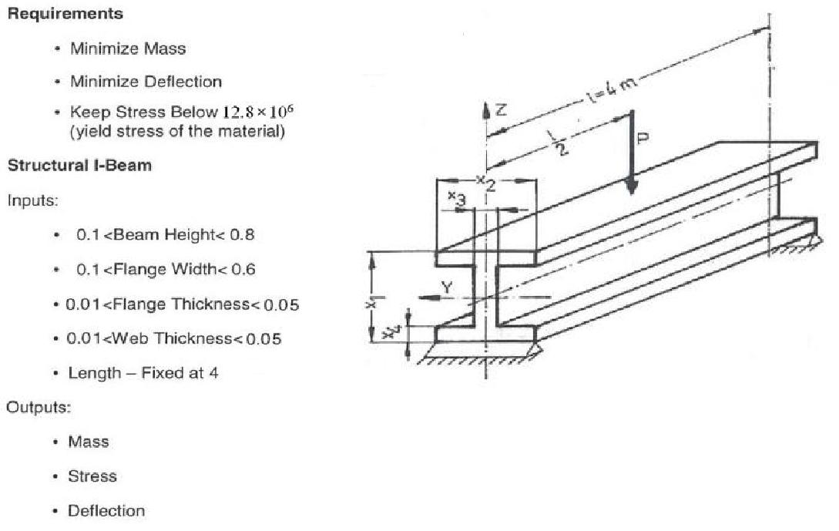

**4**

Engineering Model Description | I-Beam | Prepared by: Kaveh BABANEZHAD



**Tbl. 11 –(Non-reformulated) Model for optimization problem three**

|  |  |  |  |  |  |  |  |  |  |  |  |  |  |  |  |  |  |  |  |  |  |  |  |  |  |  |  |  |  |  |  |  |
| --- | --- | --- | --- | --- | --- | --- | --- | --- | --- | --- | --- | --- | --- | --- | --- | --- | --- | --- | --- | --- | --- | --- | --- | --- | --- | --- | --- | --- | --- | --- | --- | --- |
| Objective |  |  | Minimize= ∗∗ | | | | | | | | | | | | | | | | | | | | | | |  |  |  |  |  |  |  |
| Function(s) |  |  |  |  |  |  |  |  |  |
|  |  |  |  |  |  |  |  |  |  |  |  |  |  |  |  |  |  |  |  |  |  |  |  |  |  |  |  |  |  |  |  |
|  |  |  |  |  |  |  |  |  |  |  |  |  |  |  |  |  |  |  | 3 | |  |  |  |  |  |  |  |  |  |  |  |  |
|  |  |  | Minimize | | | | | |  |  |  | = | | |  |  |  | ∗ | | |  |  |  |  |  |  |  |  |  |  |  |  |
|  |  |  |  |  |  |  |  | 48 ∗ ∗ | | | | | | | | |  |  |  |  |  |  |  |
|  |  |  |  |  |  |  |  |  | | | |  |  |  |  |  |  |  |  |  |  |  |  |
|  |  |  |  |  |  |  |  |  |  |  |  |  |  |  |  |  |  |  |  |  |  | | | | |  |  |  |  |  |  |  |
| Output |  |  |  |  | ∗ ∗ | | | |  |  |  |  |  |  |  |  |  |  |  |  |  |  |  |  |  |  |  |  |  |  |  |  |
| Constraints | Within intervals | | = | | ∶ 0 12.8 × 10 | | | | | | | | | | | | | | | | | | 6 | |  |  |  |  |
|  | |  | |  |  |  |  |
|  |  |  | 4 ∗ | | | , |  |  |  |  |  |  |
|  |  |  |  |  |  |  |  | | | | | | | |  |  |  |  |  |  |  |  |  |  |  |  |  |  |  |
|  |  |  |  |  |  |  | |  |  |  |  |  |  |  |  |  |  |  |  |  |  |  |  |  |  |  |  |  |  |  |  |  |
| Input |  |  | ∶[0.10 0.80] | | | | | |  |  |  |  |  |  |  |  |  |  |  |  |  |  |  |  |  |  |  |  |  |  |  |  |
|  |  |  |  |  |  |  |  |  |  |  |  |  |  |  |  |  |  |  |  |  |  |  |  |  |  |  |
| Constraints |  |  | 1 |  |  |  |  |  |  |  |  |  |  |  |  |  |  |  |  |  |  |  |  |  |  |  |  |  |  |  |  |  |
|  |  | ∶[0.10 0.60] | | | | | |  |  |  |  |  |  |  |  |  |  |  |  |  |  |  |  |  |  |  |  |  |  |  |  |
| (Bounds) |  |  |  |  |  |  |  |  |  |  |  |  |  |  |  |  |  |  |  |  |  |  |  |  |  |  |
| Within intervals | | 2 |  |  |  |  |  |  |  |  |  |  |  |  |  |  |  |  |  |  |  |  |  |  |  |  |  |  |  |  |  |
|  | ∶[0.01 0.05] | | | | | |  |  |  |  |  |  |  |  |  |  |  |  |  |  |  |  |  |  |  |  |  |  |  |  |
|  |  |  |  |  |  |  |  |  |  |  |  |  |  |  |  |  |  |  |  |  |  |  |  |  |  |  |
|  |  |  | 3 |  |  |  |  |  |  |  |  |  |  |  |  |  |  |  |  |  |  |  |  |  |  |  |  |  |  |  |  |  |
|  |  |  | ∶ 0.01 0.05 | | | | | |  |  |  |  |  |  |  |  |  |  |  |  |  |  |  |  |  |  |  |  |  |  |  |  |
|  |  |  | 4 |  |  |  |  |  |  |  |  |  |  |  |  |  |  |  |  |  |  |  |  |  |  |  |  |  |  |  |  |  |
| Internal |  |  | == 4 | | |  |  |  |  |  |  |  |  |  |  |  |  |  |  |  |  |  |  |  |  |  |  |  |  |  |  |  |
| Parameters |  |  |  |  |  |  |  |  |  |  |  |  |  |  |  |  |  |  |  |  |  |  |  |  |  |  |  |  |  |
| With value(s) | | == 104 | | | | |  |  |  |  |  |  |  |  |  |  |  |  |  |  |  |  |  |  |  |  |  |  |  |  |  |
|  | == 2 × 105 | | | | |  |  |  |  |  |  |  |  |  |  |  |  |  |  |  |  |  |  |  |  |  |  |  |  |  |
|  |  |  |  |  |  |  |  |  |  |  |  |  |  |  |  |  |  |  |  |  |  |  |  |  |  |  |  |
|  |  | == 7800 | | | | | | |  |  |  |  |  |  |  |  |  |  |  |  |  |  |  |  |  |  |  |  |  |  |  |  |
|  |  |  |  | = ∗ −( −2 )( − ) | | | | | | | | | | | | | | | | | | | | | | | | | |  |  |  |
|  |  |  |  |  |  |  |  |  | 2 |  |  |  | 1 | | | |  |  | 1 | | 4 | | | | |  | 2 | | 3 |  |  |  |
|  |  |  |  |  |  |  |  |  |  | 3 | |  |  |  |  |  |  |  | 3 | |  |  |  |  |  |  |  |  |  | 2 |  |  |
|  |  |  |  |  |  | ( −2∗ ) ∗ + 2∗ ∗ + 6∗ ∗ ∗( − ) | | | | | | | | | | | | | | | | | | | | | | | | | |  |
|  |  |  |  | = | | 1 |  |  | 4 |  |  |  | 3 | | | | |  | 4 | | 2 | | | |  | 4 2 | | | 1 4 |  |  |  |
|  |  |  |  |  |  |  |  |  |  |  |  |  |  |  |  |  |  |  |  |  |  |  |  |  |  |  |  |  |  |  |
|  |  |  |  |  | |  |  |  |  |  |  |  |  |  |  |  |  |  | 12 | | | |  |  |  |  |  |  |  |  |  |  |
|  |  |  |  |  |  |  |  |  |  |  |  |  |  |  |  |  |  |  |  |  |  |  |  |  |  |  |  |  |
|  |  |  |  |  |  |  |  |  |  |  |  |  |  |  |  |  |  | 3 |  |  |  |  |  |  |  | 3 | |  |  |  |  |  |
|  |  |  |  |  |  |  |  |  |  |  | 2∗ ∗ + −2∗ ∗ | | | | | | | | | | | | | | | | | |  |  |  |  |
|  | Simplified equation(s) | | |  |  |  |  | = | |  |  |  |  |  | 4 | | | 2 |  |  | 14 | | | | | 3 | |  |  |  |  |  |
|  |  |  |  |  |  |  |  |  |  |  |  |  |  |  |  |  |  |  | 12 | | | | |  |  |  |  |  |  |  |  |  |
|  |  |  |  |  |  |  |  |  |  |  |  |  |  |  |  |  |  |  |  |  |  |  |  |  |  |  |  |
|  |  |  |  |  |  |  |  |  |  |  |  |  | = + | | | | | | | | | | | | |  |  |  |  |  |  |  |
|  |  |  |  |  |  |  |  |  |  |  |  |  |  |  |  |  |  |  | | |  |  |  |  | |  |  |  |  |  |  |  |
|  |  |  |  |  |  |  |  |  |  |  |  |  |  |  |  |  |  |  |  |  | | | | | |  |  |  |  |  |  |  |
|  |  |  |  |  |  |  |  |  |  |  |  |  |  |  |  |  |  | = |  |  | 1 |  |  |  |  |  |  |  |  |  |  |  |
|  |  |  |  |  |  |  |  |  |  |  |  |  |  |  |  |  |  | 2 | | |  |  |  |  |  |  |  |  |  |  |  |
|  |  |  |  |  |  |  |  |  |  |  |  |  |  |  |  |  |  |  |  |  |  |  |  |  |  |  |  |  |  |
|  |  |  |  |  |  |  |  |  |  |  |  |  |  |  |  |  |  |  |  |  |  |  |  |  |  |  |  |  |  |  |  |  |
| Output | Mass |  |  |  |  | = ∗∗ | | | | | | | | | | | | | | | | | | | |  |  |  |  |  |  |  |
| (To Display) |  |  |  |  |  |  |  |  |  |  |  |
|  |  |  |  |  |  |  |  |  |  |  |  |  |  |  |  |  |  |  |  |  |  |  |  |  |  |  |  |  |  |  |  |
|  | Max. |  |  |  |  |  |  | = | | | | | | | | ∗ ∗ | | | | | | | | | |  |  |  |  |  |  |  |
|  |  |  |  |  |  |  |  |  |  |  |  |  |  |  |
|  | Stress |  |  |  |  |  |  |  | | | | | | | |  |  |  |  |  |  |  |  |  |
|  |  |  |  |  |  |  |  | | | |  |  |  |  |  |  | 4 ∗ | | | | | | | |  |  |  |  |  |  |  |
|  |  |  |  |  |  |  |  |  |  |  |  |  |  |  |  |  |  |  |  | | | | | | |  |  |  |  |  |  |  |
|  | Max. |  |  |  |  |  |  |  |  |  |  |  |  |  |  |  |  |  | 3 | | |  |  |  |  |  |  |  |  |  |  |  |
|  |  |  |  |  |  |  | |  | = | | |  |  |  |  |  | ∗ | | | | | | | |  |  |  |  |  |  |  |
|  | Deflection |  |  |  |  |  |  |  |  |  |  |  |  |  |  |  |  |  |  |  |  |  |  |  |  |  |  |
|  |  |  |  |  |  |  |  |  |  |  |  |  |  |  |  |  |  |  |  |  |  |  |  |  |  |
|  |  |  |  |  |  |  |  |  | |  |  |  |  | 48 ∗ ∗ | | | | | | | | | | | |  |  |  |  |  |  |  |
|  |  |  |  |  |  |  |  |  |  |  |  |  |  |  |  |  |  |  |  |  |  |  |  | | |  |  |  |  |  |  |  |

**2. References**

1. Original publication: Unknown
2. Person(s) to contact for further information/Potential owners of the model: Jean BIGEON, G-SCOP Laboratory, France.  [jean.bigeon@grenoble-inp.f](mailto:jean.bigeon@grenoble-inp.fr)r

**3. Useful Web Links**

1. [http://en.wikipedia.org/wiki/I-bea](http://en.wikipedia.org/wiki/I-beam)m
2. [http://en.wikipedia.org/wiki/A36_stee](http://en.wikipedia.org/wiki/A36_steel)l



**5**

Engineering Model Description | I-Beam | Prepared by: Kaveh BABANEZHAD



1. [http://www.amesweb.info/SectionalPropertiesTabs/SectionalPropertiesIbeam.asp](http://www.amesweb.info/SectionalPropertiesTabs/SectionalPropertiesIbeam.aspx)x
2. [http://www.engineeringcalculator.net/beam_calculator.htm](http://www.engineeringcalculator.net/beam_calculator.html)l
3. [http://www.engineersedge.com/beam_calc_menu.shtm](http://www.engineersedge.com/beam_calc_menu.shtml)l
4. [http://www.engineeringtoolbox.com/beam-stress-deflection-d_1312.htm](http://www.engineeringtoolbox.com/beam-stress-deflection-d_1312.html)l



**6**